**CAD ASSESSMENT III**

<html>

<head>

<meta charset="UTF-8">

<title> Login </title>

<link rel="stylesheet" href="{{ url_for('static', filename='style.css') }}">

</head>

<body></br></br></br></br></br>

<div align="center">

<div align="center" class="border">

<div class="header">

<h1 class="word">Login</h1>

</div></br></br></br>

<h2 class="word">

<form action="{{ url_for('login') }}" method="post">

<div class="msg">{{ msg }}</div>

<input id="username" name="username" type="text" placeholder="Enter Your Username" class="textbox"/></br></br>

<input id="password" name="password" type="password" placeholder="Enter Your Password" class="textbox"/></br></br></br>

<input type="submit" class="btn" value="Sign In"></br></br>

</form>

</h2>

<p class="bottom">Don't have an account? <a class="bottom" href="{{url_for('register')}}"> Sign Up here</a></p>

</div>

</div>

</body>

</html>

**OUTPUT:**

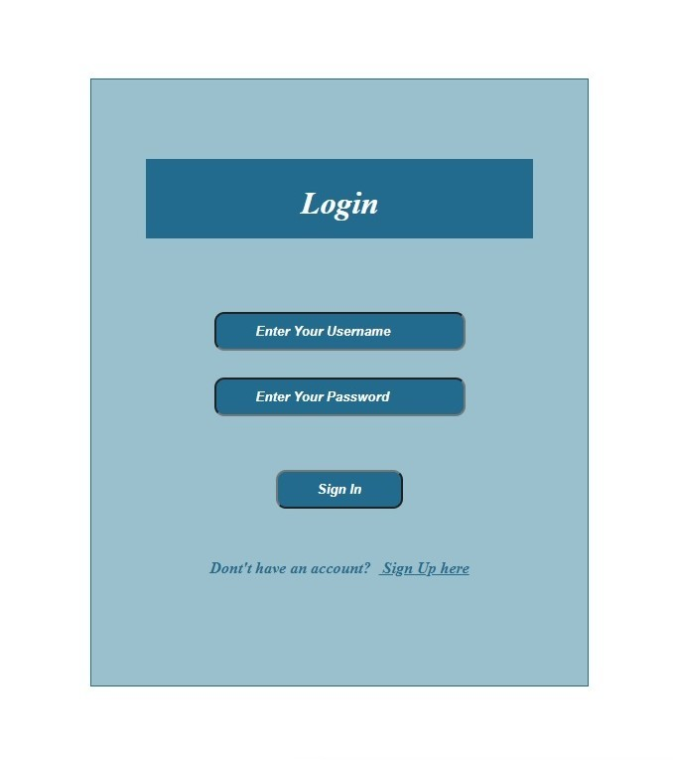

<html>

    <head>

        <meta charset="UTF-8">

        <title> Register </title>

        <link rel="stylesheet" href="{{ url_for('static', filename='style.css') }}">

    </head>

    <body></br></br></br></br></br>

        <div align="center">

          <div align="center" class="border">

             <div class="header">

                <h1 class="word">Register</h1>

             </div></br></br></br>

            <h2 class="word">

                <form action="{{ url_for('register') }}" method="post">

                  <div class="msg">{{ msg }}</div>

                    <input id="username" name="username" type="text" placeholder="Enter Your Username" class="textbox"/></br></br>

                    <input id="password" name="password" type="password" placeholder="Enter Your Password" class="textbox"/></br></br>

                    <input id="email" name="email" type="text" placeholder="Enter Your Email ID" class="textbox"/></br></br>

                    <input type="submit" class="btn" value="Sign Up"></br>

                </form>

            </h2>

            <p class="bottom">Already have an account?  <a class="bottom" href="{{url_for('login')}}"> Sign In here</a></p>

          </div>

        </div>

    </body>

</html>

<html>

    <head>

        <meta charset="UTF-8">

        <title> Index </title>

        <link rel="stylesheet" href="{{ url_for('static', filename='style.css') }}">

    </head>

    <body></br></br></br></br></br>

        <div align="center">

          <div align="center" class="border">

             <div class="header">

                <h1 class="word">Index</h1>

             </div></br></br></br>

                <h1 class="bottom">

                     Hi {{session.username}}!!</br></br> Welcome to the index page...

                </h1></br></br></br>

                <a href="{{ url_for('logout') }}" class="btn">Logout</a>

          </div>

        </div>

    </body>

</html>

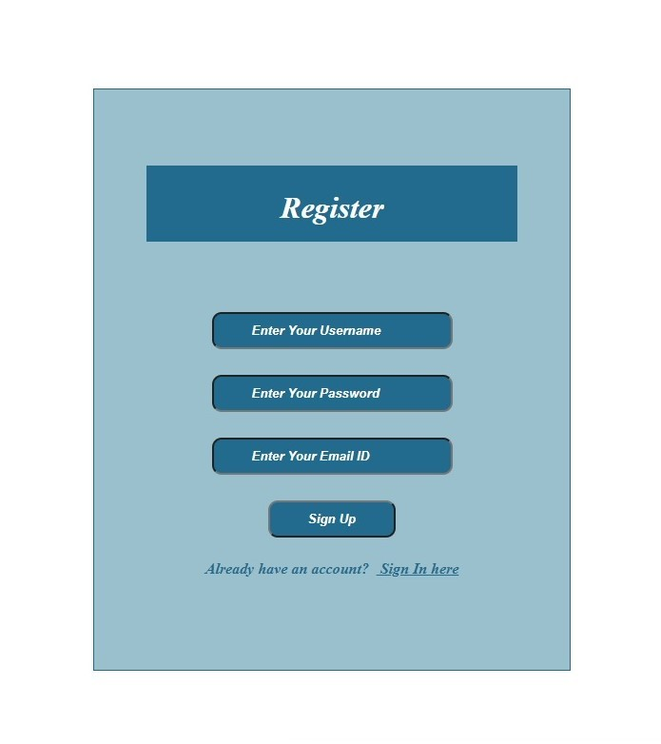**OUTPUT:**

 .header{

                padding: 5px 120px;

                width: 150px;

                height: 70px;

                background-color: #236B8E;

            }

            .border{

                padding: 80px 50px;

                width: 400px;

                height: 450px;

                border: 1px solid #236B8E;

                border-radius: 0px;

                background-color: #9AC0CD;

            }

            .btn {

                padding: 10px 40px;

                background-color: #236B8E;

                color: #FFFFFF;

                font-style: oblique;

                font-weight: bold;

                border-radius: 10px;

            }

            .textbox{

                padding: 10px 40px;

                background-color: #236B8E;

                text-color: #FFFFFF;

                border-radius: 10px;

            }

            ::placeholder {

                color: #FFFFFF;

                opacity: 1;

                font-style: oblique;

                font-weight: bold;

            }

            .word{

                color: #FFFFFF;

                font-style: oblique;

                font-weight: bold;

            }

            .bottom{

                color: #236B8E;

                font-style: oblique;

                font-weight: bold;

            }

**OUTPUT:**

